
CIRCUIT DEBUGGING ASSESSMENT
ECA0405-ANALOG CIRCUITS | CO3 | ASSESSMENT – 2
Student Name | S. Venkata Trinadh | Register No. | 192512129
Class Section | Slot C | Date | 15/08/2026
Faculty Name | Dr. Dass | Duration | 90 Minutes
Assessment Type | Circuit Debugging | Maximum Marks | 20
Assessment Objective:
To identify, analyze, and correct errors in an analog circuit, justify the debugging approach, verify the corrected circuit operation, and relate the result to CO3
Question:
CO3 Examine the frequency response characteristics of BJT and FET amplifiers at low and high frequencies to determine bandwidth, gain variation, and overall amplifier performance
CO3 AT2 Circuit Debugging:
Description:
Each student will be assigned one Circuit debugging problem 20 marks inside class. Analyze and debug one faulty analog circuit.
Simulate the corrected circuit using LTspice and verify results.
Document the debugging process, observations, and conclusions.
Upload LTspice files, simulation results, and report to GitHub.
Evaluation is based on fault identification, debugging approach, simulation accuracy, documentation, and GitHub submission.


Circuit Debugging Record
Item | Student Entry
1. Given Circuit / Circuit  Diagram | 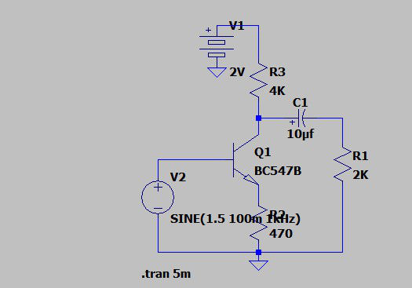
2.  Expected Circuit  Operation | The diagram depicts a Bipolar Junction Transistor (BJT) configured as a Common Emitter (CE) amplifier (note: problem text states Common Collector, but schematic physical connections define it as CE). The expected operation is linear signal amplification. This requires the BJT to be biased centrally in the active region to provide sufficient voltage headroom (VCE) for the output AC signal to swing symmetrically without clipping
3.  Observed Fault/  Symptom | The supply voltage is accidentally reduced to 2V. Under transient simulation with a 100mV peak, 1kHz input signal (DC offset 1.5V), the amplifier exhibits a severe loss of gain and the output waveform is heavily distorted/flattened, failing to accurately reproduce the input signal.
4.  Suspected Compone nt /  Connectio n | The primary DC supply voltage node (Vcc).
5.  Debuggin  g Analysis 1  Calculatio n | For linear amplification, the BJT must operate in the active region (Base-Emitter forward-biased, Base Collector reverse-biased). With Vcc severely reduced to 2V, the quiescent operating point (Q-point) shifts drastically. The standard voltage drop across the collector resistor (Rc= 4 kΩ) forces the DC collector voltage (Vc)rously close to ground. When Vc drops below the required base voltage (VB), the Base


 | Collector junction becomes forward-biased. This drives the transistor into the saturation region 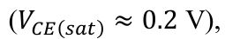 V), entirely eliminating the available voltage headroom necessary for signal swing.
6. Error  Identified | Insufficient DC supply voltage (Vcc= 2 V). This starves the circuit, preventing proper biasing and forcing the transistor out of the active linear region and into saturation, causing severe output distortion.
7.  Correctio n Made | Increased the DC supply voltage (Vcc) from the faulty 2V to a standard operational value of 12V. This restores the Q-point closer to the center of the AC load line.
8.  Corrected Circuit  Diagram | 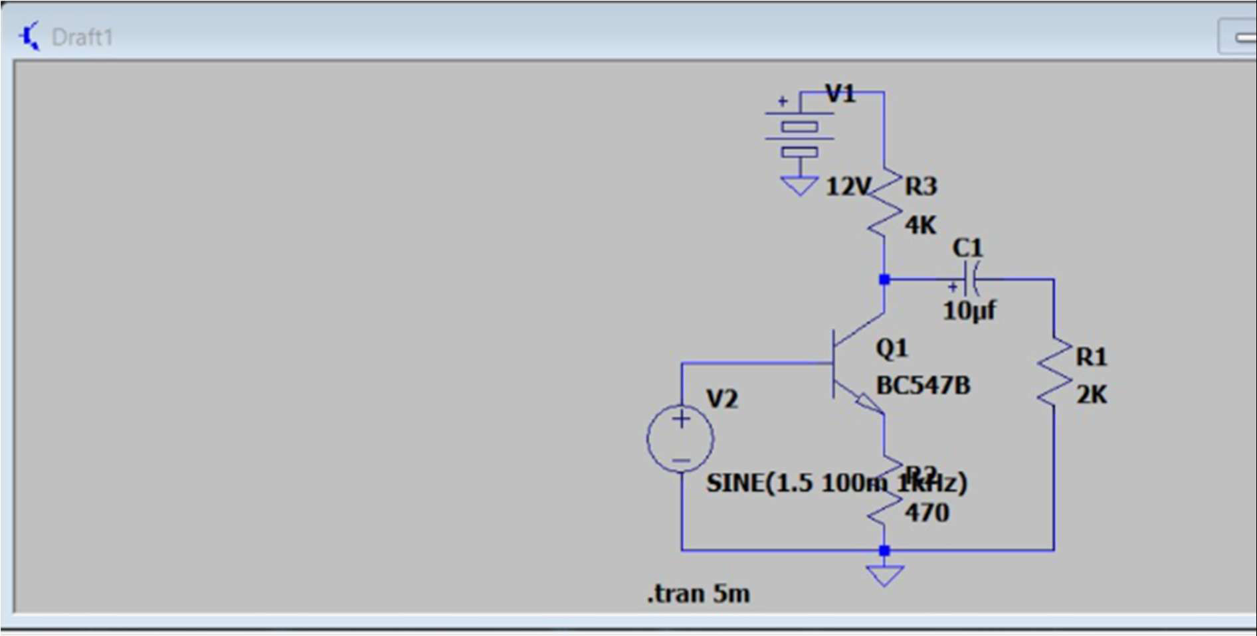
9.  Verificatio n/  Simulatio n Output | 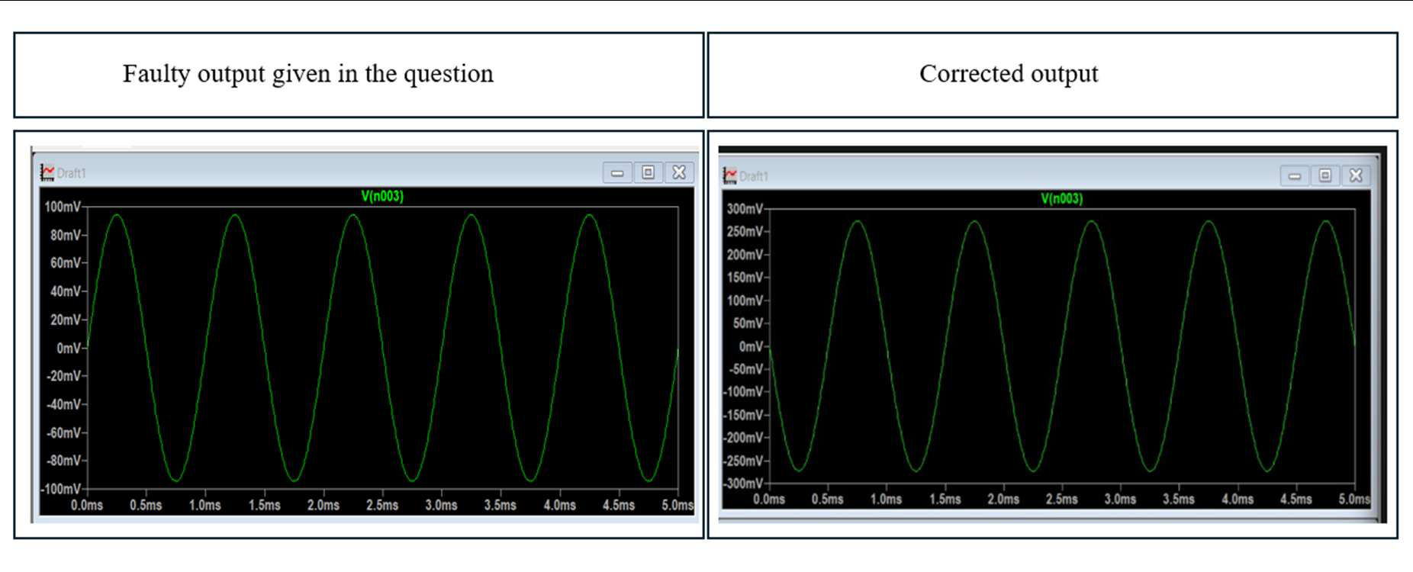  Observation: At 12V, the output waveform V(n003) successfully amplifies the 100mV peak input signal to approximately 270mV peak, yielding a clean, unclipped sine wave with a voltage gain of ~2.7.


10. Final Result & Technical Justificati on | By restoring Vcc to a nominal 12V, the transistor's operating point is shifted back into the active region. This provides sufficient VCE headroom for the output signal to swing freely during both positive and negative half-cycles. The overall amplifier performance is restored, demonstrating expected gain and  eliminating the severe distortion caused by premature saturation.


Marks Distribution
Assessment Criterion | Marks | Marks Awarded | Faculty Remarks
Problem identification & circuit understanding | 4
Fault analysis & technical calculations | 15
Correct identification of error | 3
Effective circuit correction | 3
Verification / output validation | 3
Technical explanation & documentation | 2
Total | 20

